Cape Coral Police Department
Annual Traffic Safety Plan and Crash Analysis Report
Prepared by the Special Operations Bureau | Captain of Police
City of Cape Coral, Florida
2025
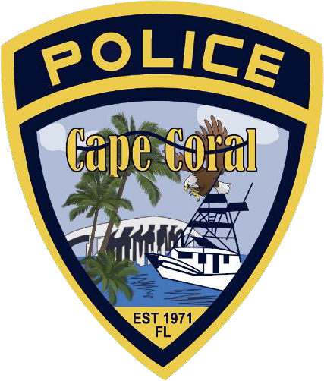
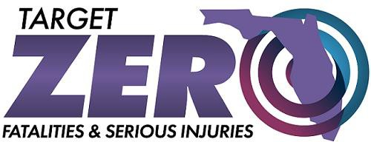

Message from the Chief of Police
Ensuring the safety of Cape Coral’s roadways is one of the Police Department’s most important responsibilities. Each day, thousands of residents, visitors, and commuters travel throughout our city, and we remain committed to protecting everyone who uses our transportation system.
As Cape Coral continues to grow, increased population and travel activity present new challenges for traffic safety. More vehicles on the road, increased pedestrian activity, and expanding commercial development require proactive planning and coordinated enforcement strategies. The Cape Coral Police Department addresses these challenges through a comprehensive approach that combines data-driven enforcement, public education, community partnerships, and collaboration with transportation professionals.
This Traffic Safety Plan reflects our commitment to using reliable data and modern policing strategies to identify crash trends, deploy enforcement resources effectively, and address the driving behaviors most often associated with serious crashes. Through targeted enforcement initiatives, community outreach programs, and participation in state and regional traffic safety efforts, our department continues working to reduce crashes, prevent injuries, and save lives.
We are also proud to partner with the Florida Department of Transportation, the Florida Department of Highway Safety and Motor Vehicles, and regional traffic safety coalitions to support the statewide Target Zero initiative, which seeks to eliminate traffic fatalities and serious injuries.
Improving roadway safety requires a shared commitment. We encourage every member of our community to drive responsibly, remain attentive behind the wheel, obey traffic laws, and always wear a seatbelt.
Together, we can make Cape Coral’s roadways safer for everyone.

Anthony Sizemore
Chief of Police
Cape Coral Police Department

Executive Summary Dashboard
The Cape Coral Police Department Traffic Safety Plan provides an annual analysis of traffic crash data, enforcement activity, and strategic initiatives designed to improve roadway safety within the City of Cape Coral.
Data from Signal Four Analytics and the Cape Coral Police Department Analytics Unit indicate that 5,741 crashes occurred in 2025, representing a 4.6% increase from 2024. While overall crashes increased slightly, several high-risk behavioral factors continue to dominate crash causation.
Key findings include:
• Distracted driving incidents decreased 38.9% from 2024, however distraction remains the leading contributing factor, accounting for approximately 36% of all crashes in 2025.
• Speeding and Aggressive Driving increased by 45.2%, indicating continued community concerns regarding unsafe driving behavior.
• Pedestrian and Bicycle Crashes increased by 33.1%, highlighting the need for continued safety initiatives for vulnerable road users.
• Alcohol Impairment was identified in 133 crashes, representing 2.3% of total crashes.
• Fatal crashes decreased slightly, with 20 fatal crashes recorded in 2025.

The Cape Coral Police Department conducted 40,389 traffic stops during 2025, resulting in:
• 24,555 Uniform Traffic Citations
• 12,281 Warning Tickets
• 396 DUI arrests
These enforcement activities were supported by FDOT-funded traffic safety grants focused on:
• Impaired Driving
• Distracted Driving
• Speed and Aggressive Driving
• Pedestrian and Bicycle Safety
Through data-driven enforcement, community outreach, and regional partnerships, the Cape Coral Police Department remains committed to reducing traffic crashes and improving roadway safety for all users.

Traffic Safety Vision
The Cape Coral Police Department supports Florida’s Target Zero initiative, which aims to eliminate traffic fatalities and serious injuries.
Traffic safety efforts extend to all roadway users, including:
• Motor vehicle drivers
• Motorcyclists
• Pedestrians
• Bicyclists
• Micromobility device users
• Transit riders
The department recognizes that achieving zero fatalities requires a comprehensive strategy involving education, enforcement, engineering partnerships, and community engagement.

Key Traffic Safety Strategies
The Cape Coral Police Department uses a comprehensive approach to improve traffic safety and reduce crashes. This approach includes three primary strategies:

Education
Public education programs are designed to inform drivers about behaviors that contribute to crashes, including distracted driving, speeding, aggressive driving, impaired driving, and failure to use occupant protection systems. Outreach initiatives help promote responsible driving habits and improve overall roadway awareness.

Enforcement
Targeted enforcement operations are conducted based on crash data, traffic complaints, and analytical trends. Officers focus on violations most associated with crashes, including distracted driving, speeding, aggressive driving, and impaired driving.

Community Partnerships
The department works closely with community organizations, traffic safety coalitions, and transportation partners to identify concerns and develop solutions that improve roadway safety for all users.

Community and Transportation Context
Cape Coral is one of the fastest-growing cities in Florida.
Between 2010 and 2024, the population increased by more than 51%, according to the United States Census Bureau. Continued residential development and economic activity have resulted in increased traffic volume and greater exposure to roadway risk factors.
As the city grows, transportation demand also increases. More residents and visitors are traveling by vehicle, bicycle, motorcycle, and on foot. Seasonal population fluctuations also influence traffic patterns. The city experiences an influx of seasonal residents and visitors during peak tourism months, further increasing traffic on roadways. These conditions require proactive planning and data-driven traffic enforcement strategies to maintain roadway safety.

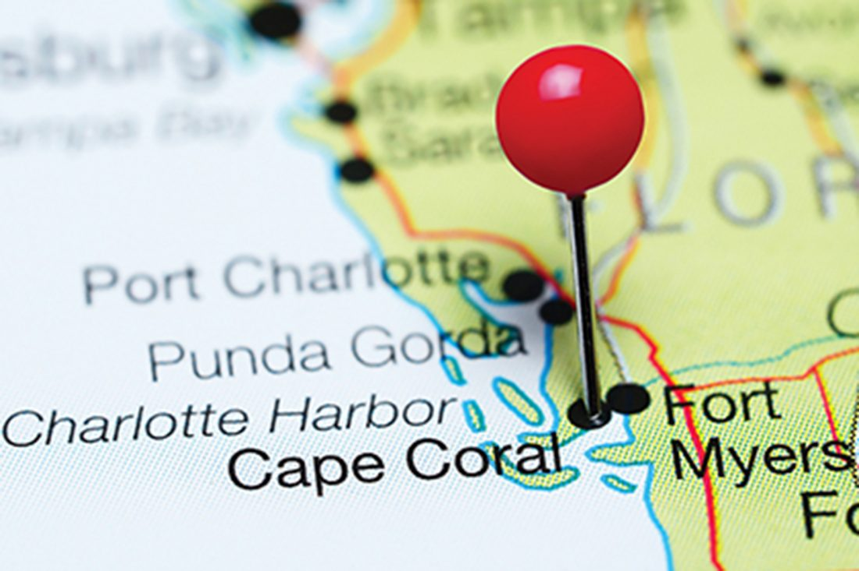

Crash Data Overview
Traffic crash data used in this report was obtained from Signal Four Analytics, a statewide crash analysis system developed by the University of Florida, as well as the Cape Coral Police Department Analytics Unit.
In 2025, the City of Cape Coral experienced 5,741 traffic crashes. While this represents a modest increase from the previous year, several important trends were identified through analysis of crash data.
Distracted driving remains the most significant contributing factor in crashes within the city. Although incidents of distracted driving decreased from 2024, distraction still accounts for more than one-third of all crashes.
Pedestrian and bicycle crashes increased significantly in 2025, underscoring the need for additional education, enforcement, and awareness of roadway safety for vulnerable road users. Speeding and aggressive driving also remain persistent concerns identified through citizen complaints and enforcement activity.
Crash data analysis helps guide enforcement strategies by identifying high-risk behaviors, locations, and time periods associated with increased crash frequency.

CALEA 61.1.1 – Compilation and review of traffic collision/crash data

2025 Traffic Crash Analysis
Emphasis Area | Crashes
Lane Departures | 1,682
Pedestrians and Bicyclists | 213
Bicycle Involved | 111
Pedestrian Involved | 94
Aging Road Users | 1,610
Motorcyclists and Motor  Scooter/Moped Riders | 93
Motorcyclists | 87
Motor Scooter/Moped Riders | 6
Commercial Motor Vehicles | 268
Teen Drivers | 833
Impaired Driving | 147
Impairment - Alcohol | 132
Impairment - Drugs | 28
Occupant Protection | 5,666
Speeding and Aggressive Driving | 366
Aggressive Driving | 247
Speeding | 119
Distracted Driving | 2,012
Work Zones | 112
Drowsy and Ill Driving | 67

In 2025, data from Signal Four Analytics highlighted concerning trends in traffic accidents. While distracted driving decreased by 38.9% from 2024, it still accounts for 36% of Cape Coral’s total crashes. Speed and aggressive driving increased by 45.2%, and pedestrian and bicyclist incidents experienced a significant spike of more than 33.1%. Distracted driving refers to any activity that “takes your hands off the wheel, your eyes off the road or mind off driving. It is an extremely risky behavior that puts everyone on the road in danger. (FLHSMV, 2025).
Throughout the year, the department received numerous complaints from concerned citizens related to speeding and aggressive driving. Notably, despite these concerns, less than 6.3% of all crashes were linked to speed and aggressive driving, while 35.1% were attributed to distracted driving.

Crash Severity and Trends

Crash Severity
Crash severity classifications are based on the most serious injury sustained by any individual involved in a traffic crash. During 2025, the majority of crashes resulted in property damage only or minor injuries.
A smaller percentage of crashes resulted in incapacitating injuries requiring immediate medical attention. Fatal crashes accounted for less than one percent of all reported crashes. Each fatal crash represents a significant loss for the community and reinforces the importance of ongoing traffic safety initiatives.
The Cape Coral Police Department’s Traffic Homicide Unit investigates serious injury and fatal crashes to determine contributing factors and identify potential prevention strategies.
Year-To-Year Comparisons

Year | Total Crashes | Incapacitating Injury | Fatal Crashes | Distracted Driving | Impairment Related | Motorcycle Related | Bike-Ped Crashes | Speed and Aggressive Driving  Related
2025 | 5,741  (+4.61%) | 93  (+3.33%) | 20  (-9.09%) | 2,012  (-38.90%) | 147  (+3.52%) | 87  (-4.40%) | 213  (+33.13%) | 247  (-1.98%)
2024 | 5,488  (-17.03%) | 90  (-11.76%) | 22  (+4.76%) | 3,293  (-11.52%) | 142  (-32.05%) | 91  (-15.74%) | 160  (-17.52%) | 252  (+8.60%)
2023 | 6,615  (+4.66%) | 102  (+3.03%) | 21  (+50.00%) | 3,722  (+44.92%) | 209  (+22.73%) | 108  (+22.73%) | 194  (+37.59%) | 232  (-6.45%)

The information provide is derived from Signal 4 Analytics and offers insight into the specific circumstances surrounding traffic crashes spanning from 2023-2025.

Crash Trends

Crash data also revealed patterns related to the timing of crashes. A greater number of crashes occurred during daytime hours, which corresponds with increased traffic volumes during commuting periods and daytime commercial activity.

Analysis of crashes by day of the week indicates that weekdays generally experience higher crash volumes due to increased traffic flow associated with work and school travel. Time-of-day analysis indicates peak crash periods during late morning and afternoon hours when traffic volumes are highest.

The data presented above is sourced from Signal Four Analytics and illustrates the total number of crashes from 2021 to 2025. Crash data indicates a 14.1% increase between 2021 and 2023, followed by a 9.64% decrease in 2024. Crash totals increased again in 2025 by 4.61%, suggesting overall stabilization but continued growth pressures related to population and traffic volume.

Crash Severity Analysis
Crash severity classifications are based on the most serious injury sustained by any individual involved in a traffic crash. During 2025, the majority of crashes resulted in property damage only or minor injuries.
A smaller percentage of crashes resulted in incapacitating injuries requiring immediate medical attention. Fatal crashes accounted for less than one-half of one percent of all reported crashes. Each fatal crash represents a significant loss for the community and reinforces the importance of ongoing traffic safety initiatives.
The Cape Coral Police Department’s Traffic Homicide Unit investigates serious injury and fatal crashes to determine contributing factors and identify potential prevention strategies.

The data above were derived from Signal Four Analytics and depict total crash severity for 2025. Severity is defined as the severity of a crash based on the most severe injury to any person in the crash. 18.55% of the crashes resulted in possible injuries reported by an involved person. 14.23% of crashes resulted in reported non-incapacitating injuries, lacerations, scrapes, or bruises. 1.57% of crashes resulted in incapacitating injuries, which are disabling injuries, such as broken bones or severed limbs, and would require immediate medical attention. 0.38% of all crashes resulted in the death of a person involved in the crash, a driver, passenger, pedestrian, or bicyclist, and occurred within 30 days after a crash.

Crash Type vs. Crash Severity
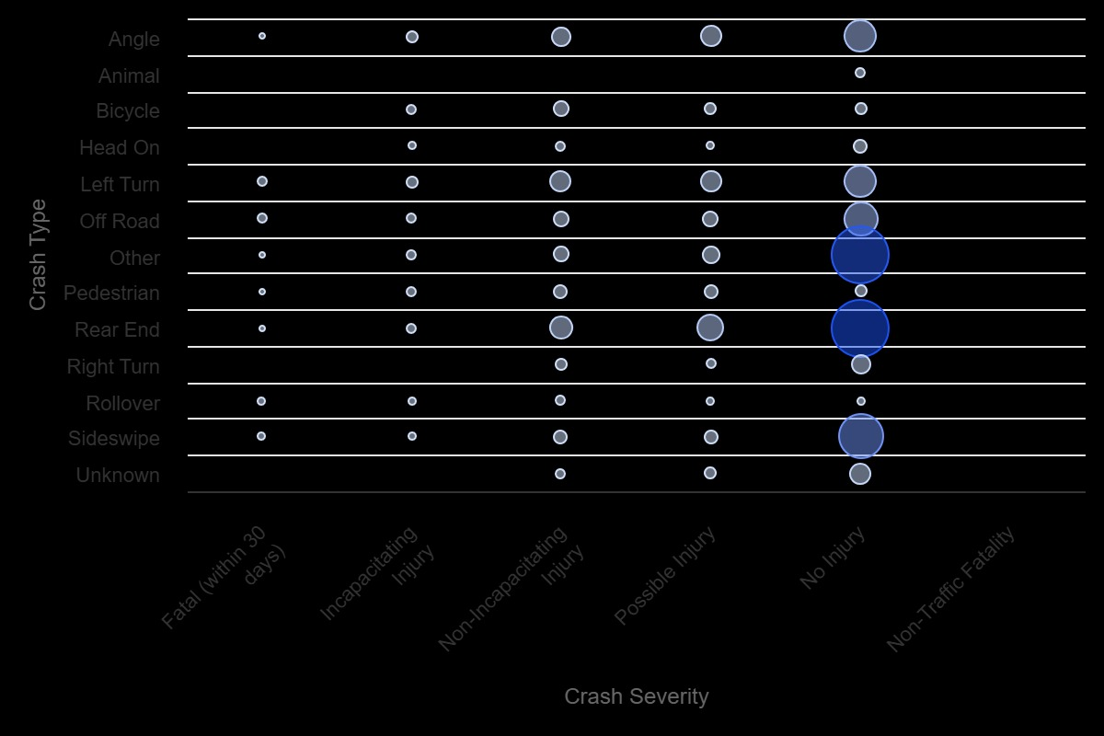

The data above were derived from Signal Four Analytics and presented crash severity by crash type or causation. The data indicated that rear-end crashes and other (non-specific) crashes accounted for the majority of crashes.

Crash Time and Location Analysis
Comparison of the Number of Crashes in Day and Night:
The information above, obtained from Signal Four Analytics, illustrates the total number of crashes that happened during both daytime and nighttime. Drivers are more likely to be involved in crashes during daytime hours, which corresponds with higher traffic volumes.
Crashes Day vs. Night

Analysis of Crashes: Days and Time Slots Throughout the Week:
The data below were derived from Signal Four Analytics and depict the total number of crashes that occurred each day of the week and within specific groups.

Crashes Day of the Week
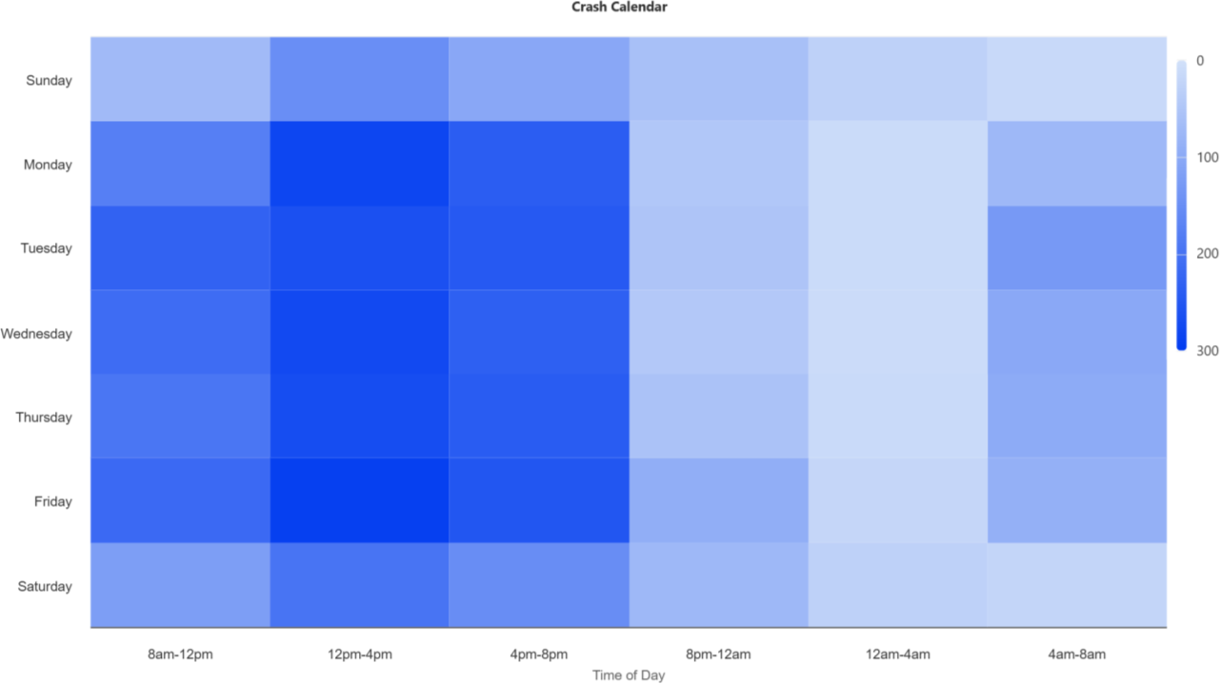

Analysis of Crash Incidents by Day of the Week:
The information displayed below is sourced from Signal Four Analytics, reveals the total number of crashes happening each day of the week. Notably, Sunday experienced the lowest number of crashes, while Friday saw the most. Crashes on Monday are the lowest on weekdays.

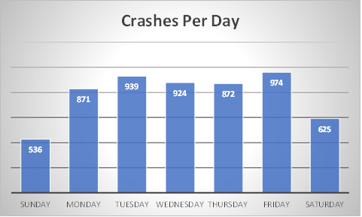

Crashes Per Time Group:
The data presented below, gathered from Signal Four Analytics, illustrates the total number of crashes for each time group. Notably, the fewest crashes occurred between 12 AM and 4 AM, while the period from 12 PM to 4 PM recorded the most.


Crashes Per Time Group
1858
1497
1288
524
436
138
8A-12P
12P-4P
4P-8P
8P-12A
12A-4A
4A-8A

Analysis of Crashes Involving Alcohol:
The data below, sourced from Signal Four Analytics, outlines the number of crashes attributed to alcohol impairment. Alcohol impairment, suspected by law enforcement, refers to a decrease in the physical ability of a driver or non-motorist involved in a traffic crash.
Out of all crashes, 5,608 cases, or 97.7%, were not suspected of involving alcohol impaired drivers. In contrast, 133 crashes, accounting for 2% of all crashes, were identified as having alcohol impairment as a causative factor. The number of alcohol-impaired crashes decreased from 143 in 2024 to 133 in 2025, or by -6.99%.

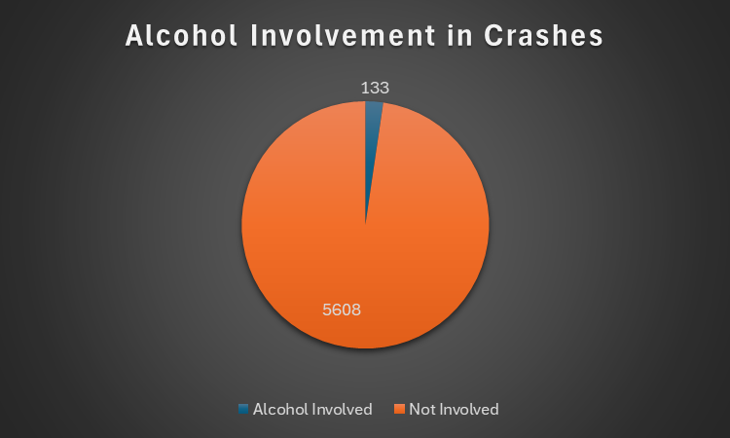

Analysis of the Major Crash Investigations from 2015 to 2025:
The data reveals that major crash investigations dropped from 49 in 2024 to 48 in 2025. Fatal crashes decreased to 20 in 2025 from 23 in 2024, a reduction of 13.04%.

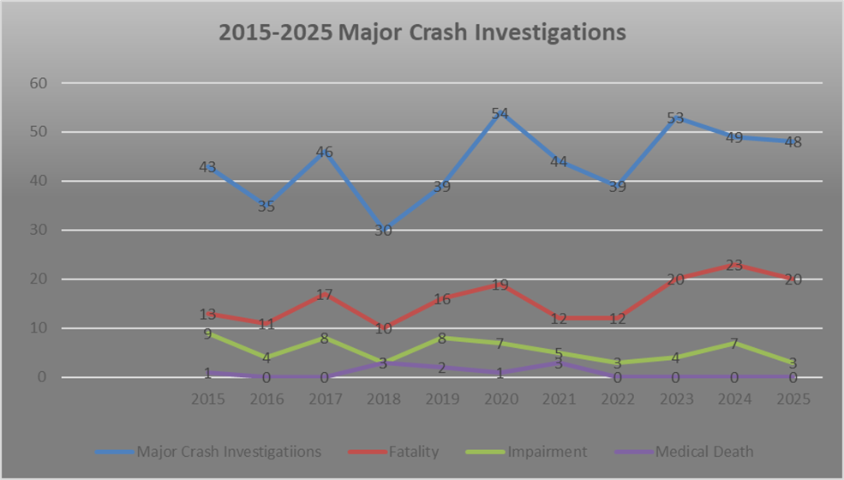

High Crash Corridor Analysis
Crash corridor analysis identifies major roadway segments where crashes occur most frequently. These corridors receive increased enforcement attention and traffic safety planning.
- Pine Island Road
- Del Prado Boulevard
- Cape Coral Parkway
- Veterans Parkway
- Santa Barbara Boulevard

The Heat Maps below are sourced from Signal Four Analytics and show traffic crash data. The red heat marks highlight the primary areas where crashes occurred, aligning with High Crash Corridors.

NE Pine Island Road

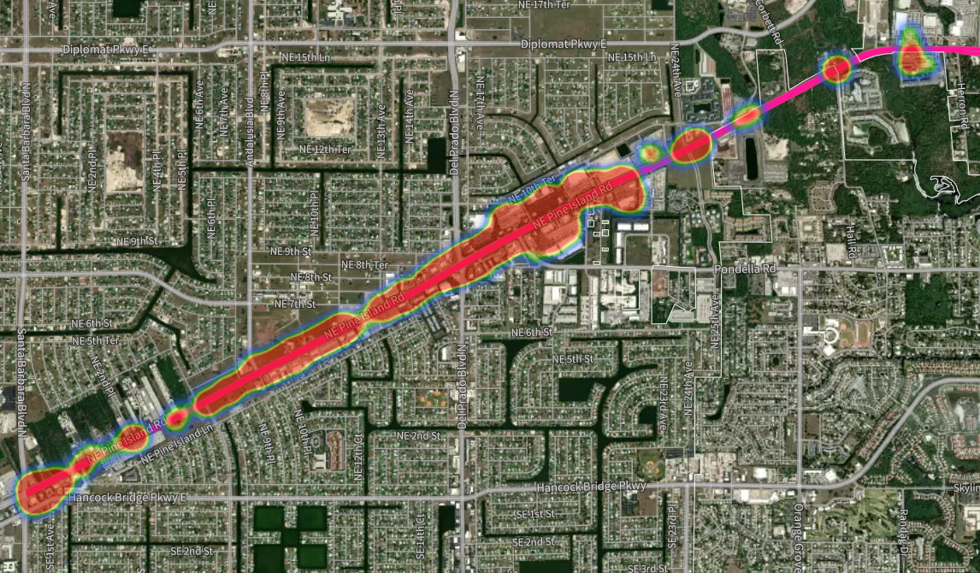

SW Pine Island Road
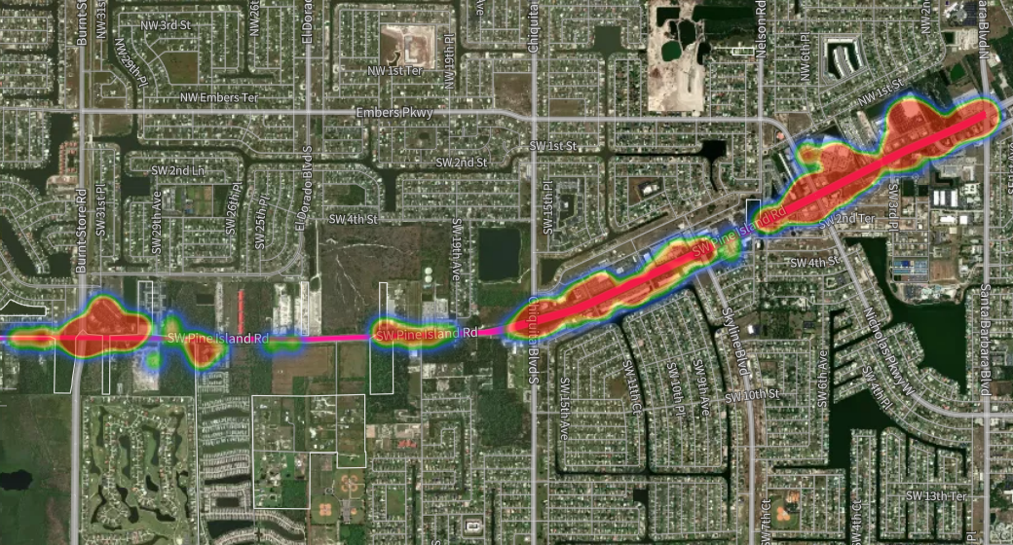

Del Prado Boulevard N
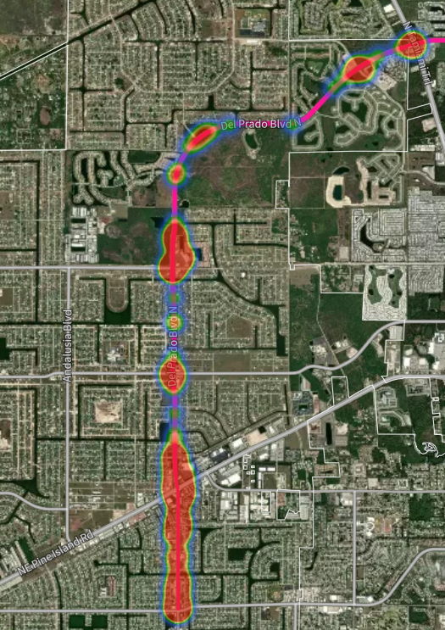

Del Prado Boulevard S
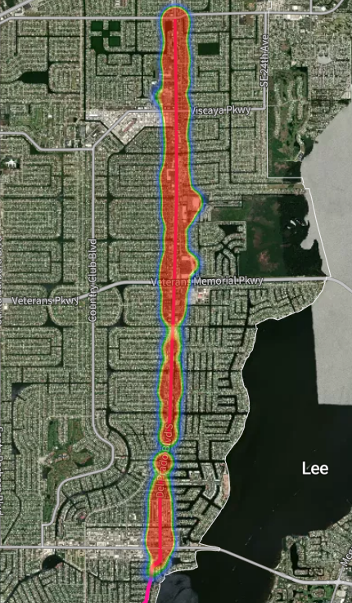

Cape Coral Parkway E
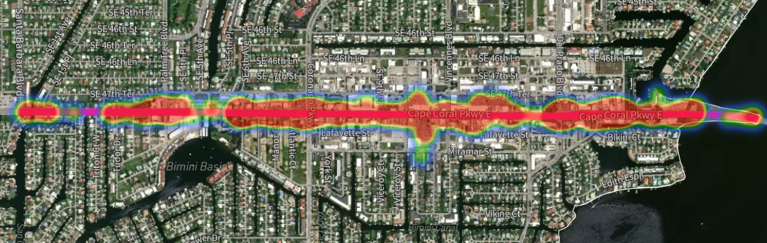

Cape Coral Parkway W
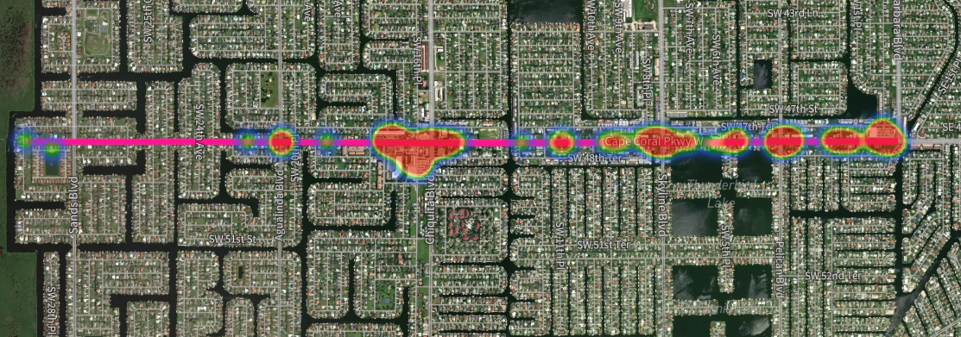

Veterans Memorial Parkway
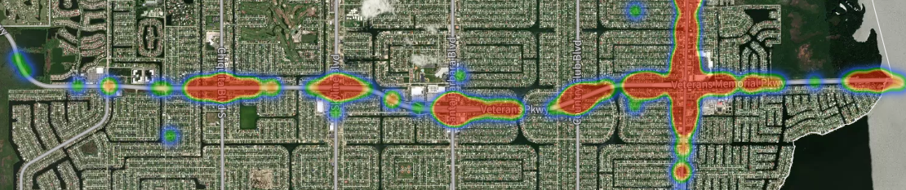

Santa Barbara Boulevard S
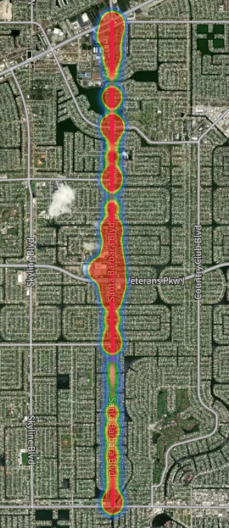

Santa Barbara Blvd N
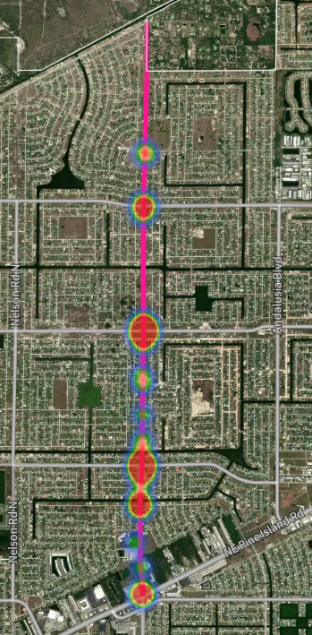

Precinct Crash Heat Maps
To improve response times and enhance operational effectiveness, the Cape Coral Police Department transitioned from three patrol districts to four patrol precincts in 2024. The city is now divided into Northwest, Northeast, Southwest, and Southeast districts.
Crash heat maps generated through Signal Four Analytics identify concentrations of crashes along major traffic corridors within each precinct. These analytical tools help supervisors identify high-risk locations and deploy enforcement resources where they are most needed.
Northwest Precinct Crash Heat Map
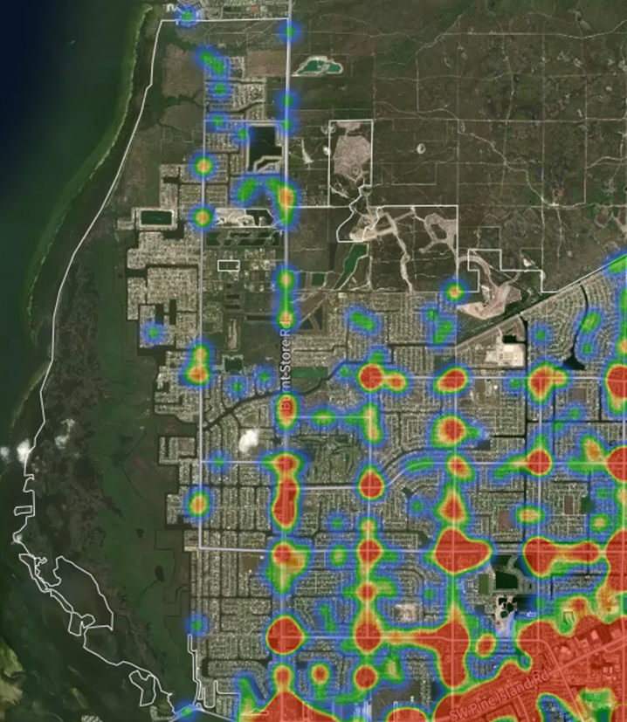
The information above, sourced from Signal Four Analytics, shows traffic crash data. The red heat marks highlight the primary areas where crashes occurred, aligning with the main traffic corridors reported.
Northeast Precinct Crash Heat Map
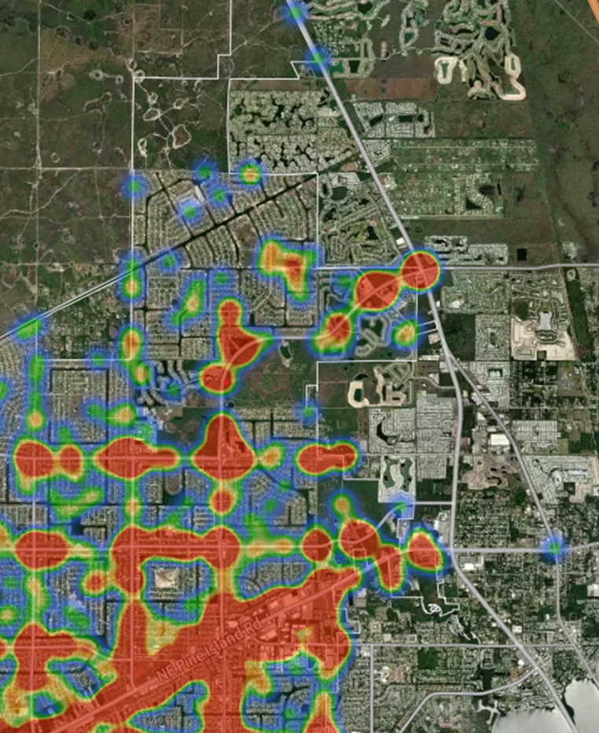
The information above, sourced from Signal Four Analytics, shows traffic crash data. The red heat marks highlight the primary areas where crashes occurred, aligning with the main traffic corridors reported.

Southwest Precinct Crash Heat Map
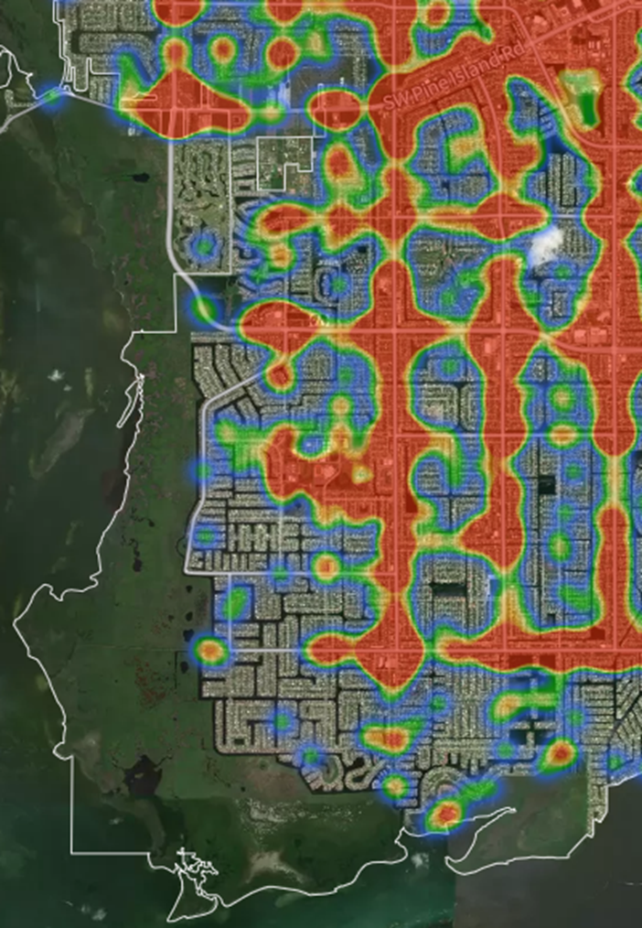
The information above, sourced from Signal Four Analytics, shows traffic crash data. The red heat marks highlight the primary areas where crashes occurred, aligning with the main traffic corridors reported.

Southeast Precinct Crash Heat Map
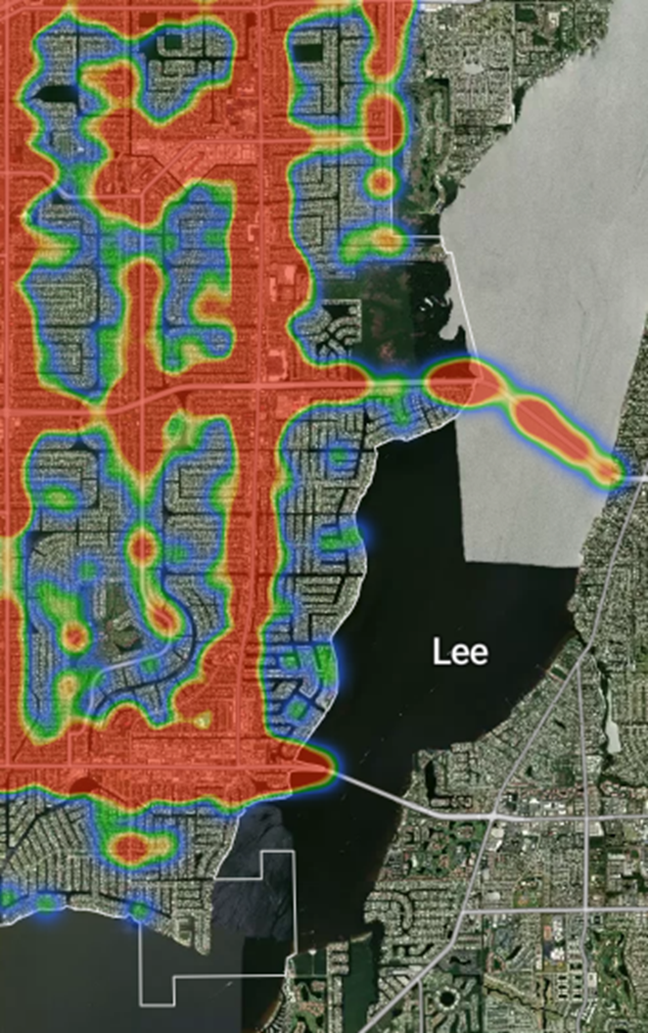
The information above, sourced from Signal Four Analytics, shows traffic crash data. The red heat marks highlight the primary areas where crashes occurred, aligning with the main traffic corridors reported.

Traffic Enforcement Activity (CALEA 61.1.1)
Traffic enforcement remains a critical component of the department’s traffic safety strategy. During 2025, Cape Coral police officers conducted more than 40,000 traffic stops throughout the city.
These enforcement activities resulted in over 24,000 Uniform Traffic Citations and more than 12,000 warning citations. Officers use discretion when conducting traffic stops, issuing warnings when education is more effective, and issuing citations when enforcement is warranted.
Targeted enforcement operations are directed toward violations that contribute most frequently to crashes, including distracted driving, speeding, aggressive driving, and impaired driving.

CALEA 61.1.1 – Compilation and Review of Traffic Enforcement Activities Data

The data above was derived from the Cape Coral Police Department Analytics Unit and depicts the total number of traffic stops, UTCs (Uniform Traffic Citations), and WTs (Warning Tickets) by month. An officer may issue a WT (education) or a UTC (enforcement) based on discretion.
Based on the data above, officers conducted 40,389 traffic stops. Officers issued 24,555 UTCs (60.7%) and 12,281 warnings (30.4%) during those traffic stops.

The above data was derived from the Cape Coral Police Department Analytics Unit and depicts daily traffic stops. The data indicates that Tuesday is the day with the highest number of traffic stops, WTs, and UTCs of all the days of the week.

The data above was derived from the Cape Coral Police Department Analytics Unit and depicts the total number of DUI (Driving Under the Influence) arrests by geographical district. The data indicates that the Southeast district had the highest number of DUI arrests compared to the other districts. This may be influenced by the concentration of restaurants, entertainment venues, and nightlife establishments within the Southeast District.

The data above was derived from the Cape Coral Police Department Analytics Unit and depicts the total number of DUI (Driving Under the Influence) arrests by month for 2025.

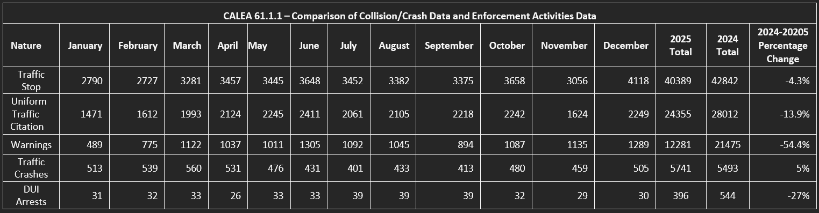

The data shown above was derived from the Cape Coral Police Department Analytics Unit and Signal Four Analytics (regarding traffic crashes). It depicts the monthly statistics for traffic stops to include the conclusion of the traffic stops, such as WTs (education), UTCs (enforcement), and DUI arrests (enforcement).
The data provided by the Cape Coral Police Department Analytics Unit is combined data derived from available legacy and current records management systems.

Selective Enforcement Strategies (CALEA 61.1.1)
The Cape Coral Police Department enforces a zero-tolerance approach to dangerous driving, deploying aggressive, data-driven strategies to eliminate behaviors that put the public at risk. Personnel and resources are strategically concentrated in areas with the highest crash potential, guided by a comprehensive analysis of collision history, enforcement records, traffic volume, and roadway conditions. By pinpointing specific locations, times, and high-risk violations, the department conducts targeted patrols and high-visibility enforcement operations to address unsafe driving aggressively before crashes occur. Enforcement prioritizes violations most likely to cause serious injury or death, ensuring that every action is deliberate, decisive, and responsive to the City’s evolving traffic environment, including seasonal population surges.
Supervisors provide strict oversight, ensuring all enforcement efforts align with the department’s public safety mandate. Advanced tools such as Signal Four Analytics allow real-time monitoring of emerging trends, evaluation of enforcement effectiveness, and rapid adjustment of deployment strategies to maintain maximum impact. This uncompromising, intelligence-driven approach ensures enforcement is proactive, relentless, and resolutely focused on reducing crashes, preventing injuries, and protecting residents and visitors—sending a clear message that unsafe driving will not be tolerated on Cape Coral streets.

Strategic Enforcement Priorities
Based on crash data analysis, the Cape Coral Police Department has identified the following enforcement priorities:
- Reduce distracted driving through targeted enforcement operations
- Increase high-visibility patrols along major crash corridors
- Expand DUI enforcement and impaired driving detection
- Enhance pedestrian and bicycle safety initiatives
- Deploy data-driven patrol strategies based on crash heat maps

Deployment of Traffic Enforcement Personnel (CALEA 61.1.1)
The Cape Coral Police Department deploys traffic enforcement personnel as a core enforcement strategy. These resources encompass all sworn members of the Cape Coral Police Department, which include the following:
- Patrol Officers
- Traffic Motor Officers
- Aggressive Driving Officers
- DUI Enforcement Officers
- Traffic Homicide Investigators
- K9 Officers
These personnel work collectively to address dangerous driving behaviors, respond to crashes, and investigate serious collisions within the city.

Grant-Funded Traffic Safety Programs
The State Safety Office of the Florida Department of Transportation (FDOT) provides subgrants to traffic safety partners that undertake priority-area programs and activities to enhance traffic safety and reduce crashes, serious injuries, and fatalities. These subgrants are awarded to address traffic safety deficiencies, expand ongoing activities, or develop new programs. They serve as "seed" money for state and local safety-related agencies to help develop and implement programs focused on priority traffic safety areas. Funding for these subgrants is allocated annually to states from the National Highway Traffic Safety Administration (NHTSA) based on a formula that considers population and road miles.
These grants support targeted enforcement operations, officer training, public education campaigns, and equipment necessary to address the most significant traffic safety concerns identified through crash analysis.

The Cape Coral Police Department receives funding for the following 2025 programs:
Grant Budget | Grant Number | Budgeted Amount | Phase
Speed and Aggressive Driving | SC-2024-00069 | $75,000.00 | 2025
DRE | M5X-2024-00246/G2O72 | $6,000.00 | 2025
HVE Impaired Driving | M5HVE-2024-00167 | $75,000.00 | 2025
Distracted Driving | DD-2024-00068 | $75,000.00 | 2025
HVE Ped/Bike | 433144-1-8404/G2M61 | $26,184.64 | 2025
Teen Driving | TPS-2025-00275 | $24,000 | 2025

The FY2027 Florida Department of Transportation Highway Safety Matrix–Ranking of Florida Cities determines the department’s eligibility for grant funding. According to this report, Cape Coral was ranked in the following categories. The rankings are based on data from 2020-2024, covering serious injuries and fatalities across 38 cities with populations of 75,000 or more.

FY2027 FDOT Highway Safety Matrix - Ranking of Florida Cities
(Based on total actual serious injuries and fatalities during 2020-2024)
Group 1 - Population of 75,000 and above - 38 Cities
Category Florida City (Group 1) | Ranking
Aging Road Users (Drivers 65+) | 9
Distracted Driving | 3
Impaired Driving | 5
Motorcyclist | 10
Occupant Protection | 8
Pedestrian or Bicyclist | 21
Speeding or Aggressive Driving | 10
Teen Drivers | 12
Work Zones | 20

The Florida Department of Transportation Highway Safety Matrix serves as a tool for objectively prioritizing safety projects in areas with the highest fatalities and serious injuries. These matrices identify counties and cities, varying in size, that rank in the Top 40 percent for fatalities and serious injuries. The matrices presented above are for the City of Cape Coral, which is in the top 40 percent (represented in red) for aging road users, distracted driving, impaired driving, motorcyclists, occupant protection, speeding or aggressive driving, and teen drivers. This means there is greater potential to reduce fatalities and serious injuries through prioritized safety initiatives.
Grant-Funded Traffic Operations
Category | 2024 | 2025 | Percentage  Change
Impaired Driving | 15 | 5 | -66.67%
HVE Ped/Bike | 17 | 21 | +23.53%
Speed/Aggressive  Driving | 14 | 10 | -28.57%
Distracted  Driving | 18 | 3 | -83.33%

Community Outreach and Partnerships
The Cape Coral Police Department engages in various community outreach activities to promote safety and address citizen concerns. These efforts include:
- Traffic Safety Meetings: The department attends local traffic safety meetings to provide input and address citizens' concerns. This involves discussing various safety issues, gathering feedback, and collaborating on solutions to improve traffic conditions in the community.
- Citizen’s Police Academy: The department hosts the Citizen’s Police Academy, a training program for community members. This program offers insights into the police department's operations, including law enforcement techniques, community policing strategies, and crime prevention.
- Lee County Coalition for a Drug-Free Southwest Florida: The department works closely with this coalition to participate in the Drug-House Odyssey, an educational program to raise awareness about the dangers of impaired driving, distracted driving, and aggressive driving. Through this program, they educate the public, particularly young drivers, on the risks associated with these behaviors.
- Community Engagement and Outreach Meetings: A supervisor from the Special Operations Bureau within the Cape Coral Police Department attends various community meetings to discuss specialized topics and initiatives. These meetings include:
- Neighborhood Watch meetings
- Traffic-related community group meetings
- School safety and educational programs
- Local government meetings

By participating in these activities, the Cape Coral Police Department actively engages with the community, promotes safety, and effectively addresses citizens' concerns.
Meeting Identification | Meeting Description
Bicycle and Pedestrian Coordinating  Committee | Bicycle and pedestrian safety concerns
Traffic Management and Operations  Committee | Identification of congestion, traffic signals,  signage, safety, and traffic issues
Local Coordinating Board | Transportation for disadvantaged citizens
Community Traffic Safety Team | A team that responds to specific traffic  concerns and provides solutions
Traffic Incident Management | Team to review major traffic crashes/traffic concerns and provide solutions to reduce and prevent secondary traffic crashes

CALEA Compliance Review
This document satisfies the annual review requirement of CALEA Standard 61.1.1, which requires agencies to compile, analyze, and review traffic crash and enforcement data in order to direct selective enforcement activities.

Conclusion
In accordance with CALEA Standard 61.1.1, the Cape Coral Police Department conducts an annual analysis of traffic crash data to identify trends, contributing factors, and locations requiring targeted enforcement or engineering review. The department will continue to analyze crash data, deploy targeted enforcement strategies, and engage the community to reduce crashes, prevent injuries, and save lives. Through collaboration, innovation, and data-driven policing strategies, the Cape Coral Police Department remains committed to improving roadway safety for all residents and visitors of Cape Coral.

Appendix
Florida Department of Highway Safety and Motor Vehicles (FLHSMV). (2025). Put It Down: Focus on Driving. Retrieved from https://www.flhsmv.gov
Statistics, U. B. (2025, June 11). Retrieved from: https://www.bls.gov/eag/eag.fl_capecoral_msa.htm#eag_fl_capecoral_msa.f.3
United States Census Bureau. (2024, July 1). Quick Facts Cape Coral City, Florida. Retrieved from: https://www.census.gov/quickfacts/fact/table/capecoralcityflorida

